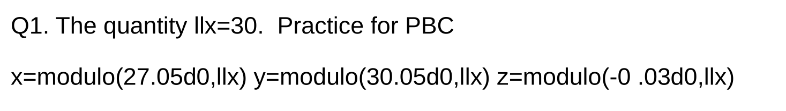
Ans->
x = 27.050000000000001
y = 5.0000000000000711E-002
z = 29.969999999999999

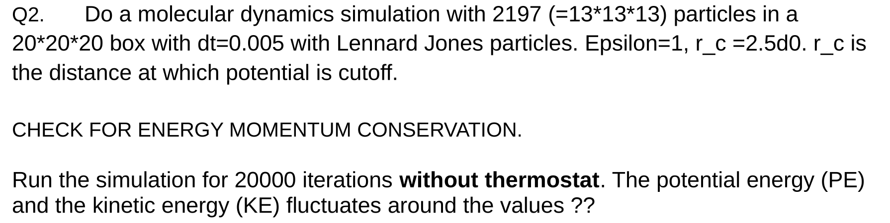
Ans->
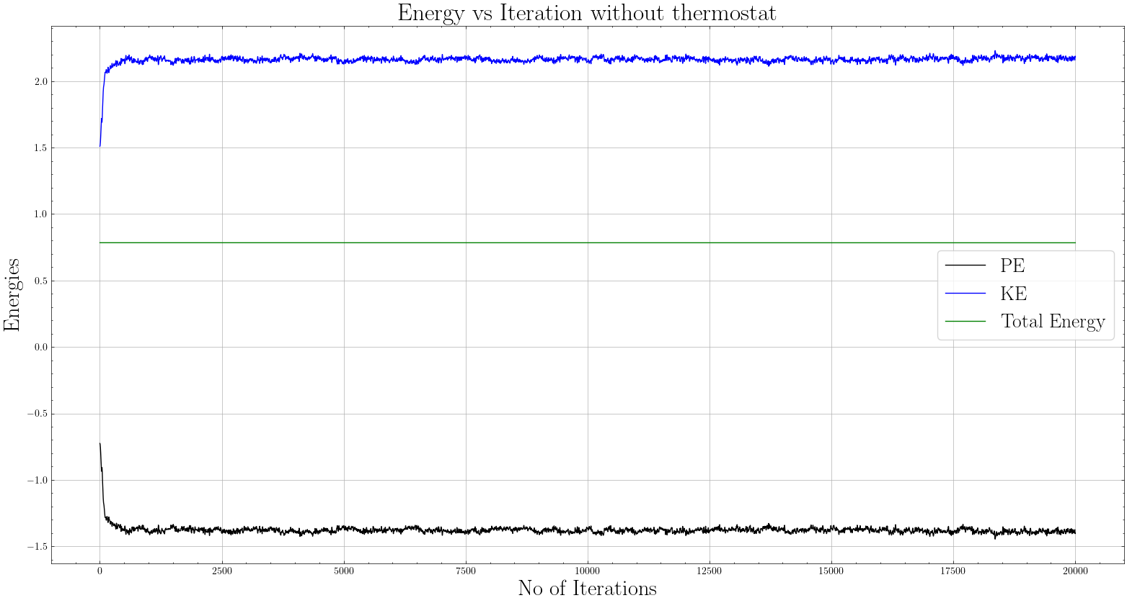
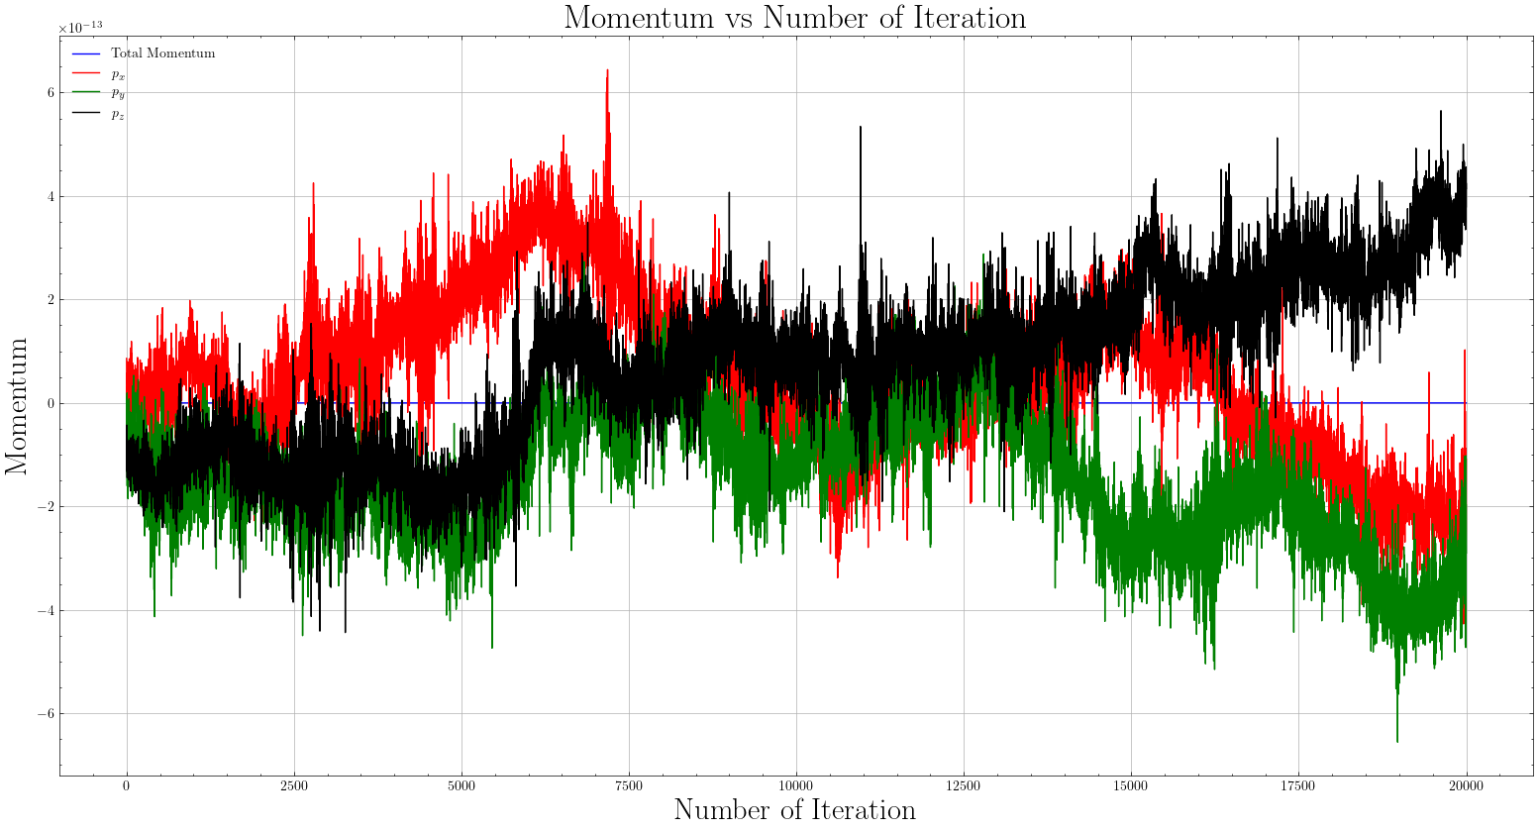
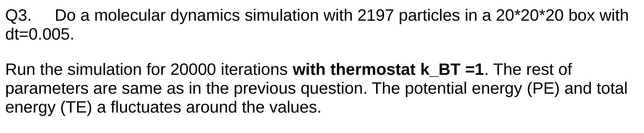
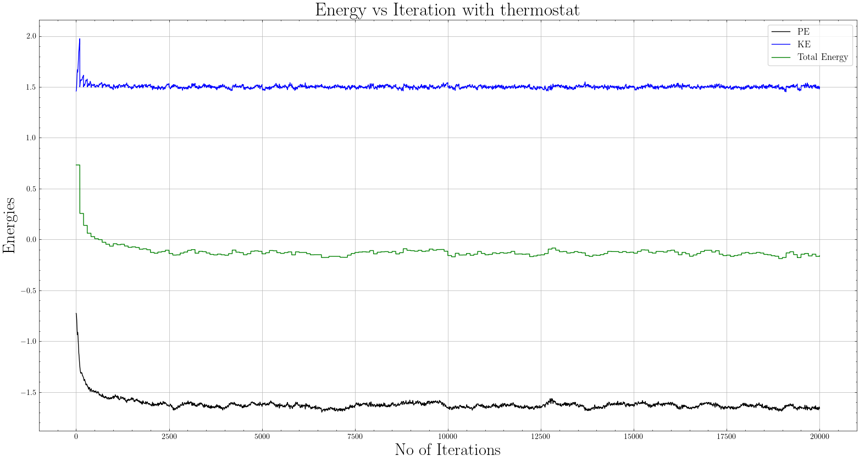

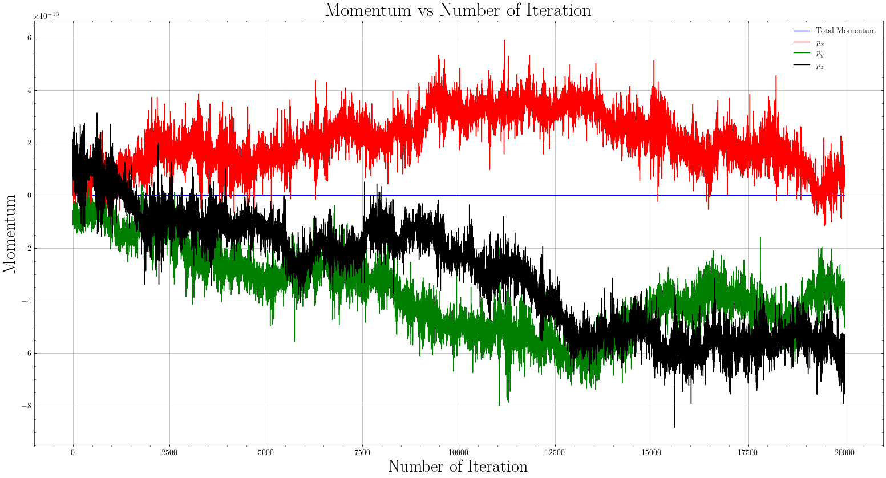

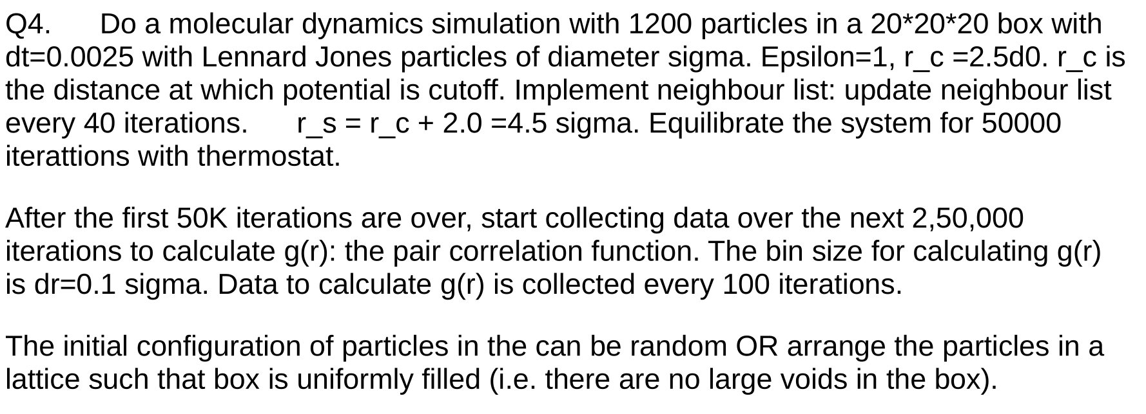
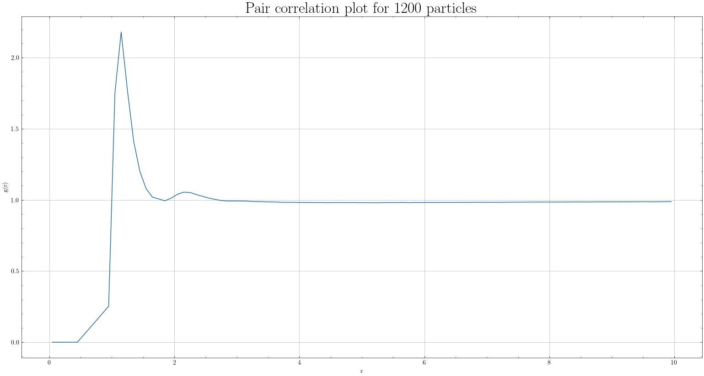
Ans-->

Q5. The height of the first peak of the pair correlation function g(r) is:(1.1500,2.2047147906209)


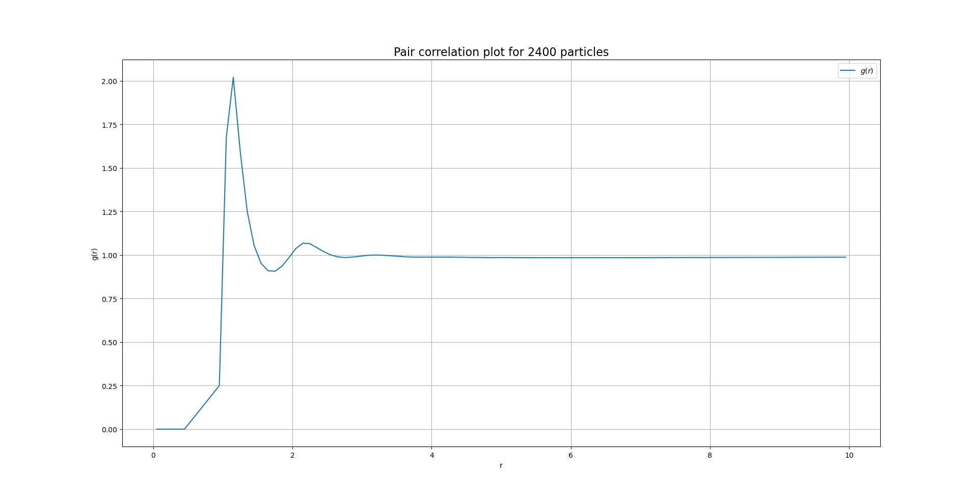

second peak=(2.190,1-069)
first peak=(1.150,2.0194)

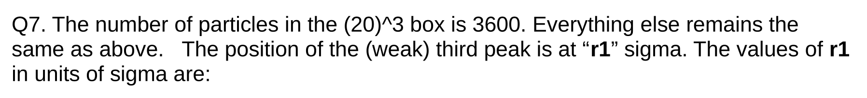

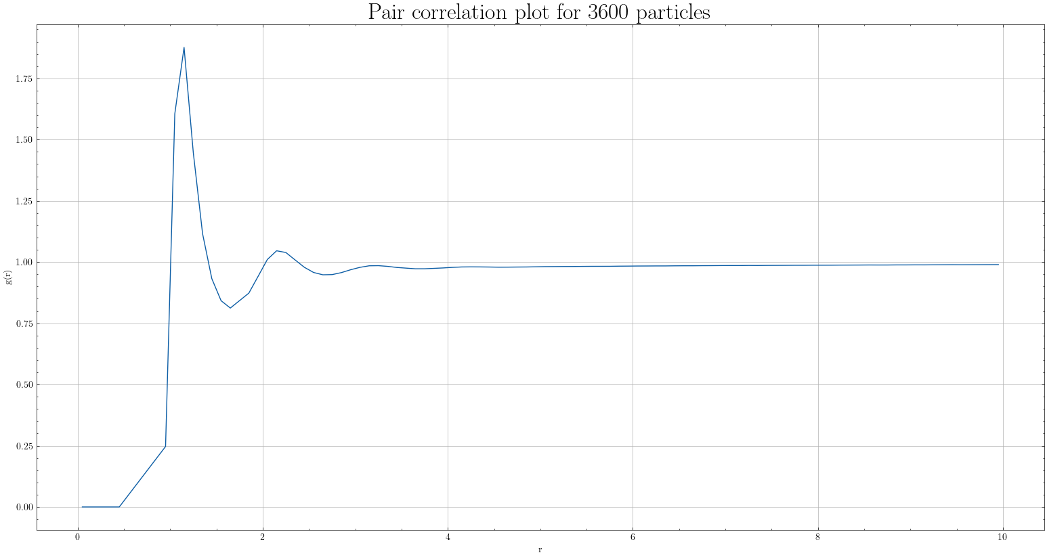
1st peak(1.149994,1.87642)
2nd peak (2.168,1.046)
weak 3rd peak: (3.148,0.993)

